Top of Form

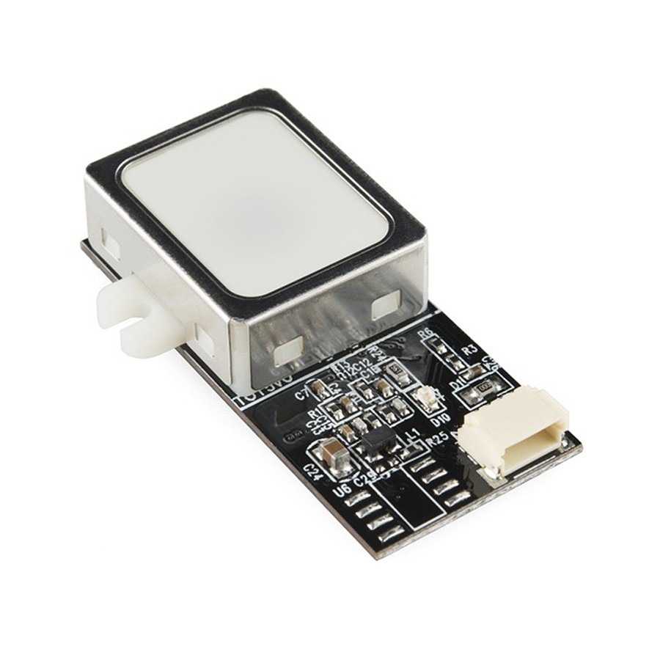

MORE VIEWS

* [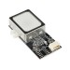](http://www.instock.pk/fingerprint-scanner-sensor-module-ttl-gt-511c3.html)

**FINGERPRINT SCANNER SENSOR MODULE- TTL (GT-511C3)**

PKR 14,350.00

AVAILABLE ON DEMAND

[Sign up for price alert](http://www.instock.pk/productalert/add/price/product_id/323/uenc/aHR0cDovL3d3dy5pbnN0b2NrLnBrL2ZpbmdlcnByaW50LXNjYW5uZXItc2Vuc29yLW1vZHVsZS10dGwtZ3QtNTExYzMuaHRtbA,,/)

The module is small and easy to mount using two mounting tabs on the side of the sensor. The on-board JST-SH connector has four signals: Vcc, GND, Tx, Rx. A compatible JST-SH pigtail can be found in the related items below. Demo software for PC is available in the documents below, simply connect the module to your computer using an FTDI Breakout and start the software to read fingerprints!

Bottom of Form

The module itself does all of the heavy lifting behind reading and identifying the fingerprints with an on-board optical sensor and 32-bit CPU. All you need to do is send it simple commands. To get started, just register each fingerprint that you want to store by sending the corresponding command and pressing your finger against the reader three times. The fingerprint scanner can store different fingerprints and the database of prints can even be downloaded from the unit and distributed to other modules. As well as the fingerprint "template," the analyzed version of the print, you can also retrieve the image of a fingerprint and even pull raw images from the optical sensor!  
  
This is the updated version of the GT-511 which has an increased memory capacity. The module can store up to 200 different fingerprints (that's 10x more than the old version!) and is now capable of 360° recognition.  
  
The module is small and easy to mount using two mounting tabs on the side of the sensor. The on-board JST-SH connector has four signals: Vcc, GND, Tx, Rx. A compatible JST-SH pigtail can be found in the related items below. Demo software for PC is available in the documents below, simply connect the module to your computer using an FTDI Breakout and start the software to read fingerprints!

**SPECIFICATION:**

***1) High-Speed, High-Accuracy Fingerprint Identification using the SmackFinger 3.0 Algorithm  
2) Download Fingerprint Images from the Device  
3) Read and Write Fingerprint Templates and Databases  
4) Simple UART protocol (Default 9600 baud)  
5) Capable of 1:1 Verification and 1:N Identification  
6) Dimensions: 37 x 17 x 9.5 mm***

## Pin Numbering, Functions and Specifications

The image below shows the pin numbers of the GT-511C3 fingerprint scanner.

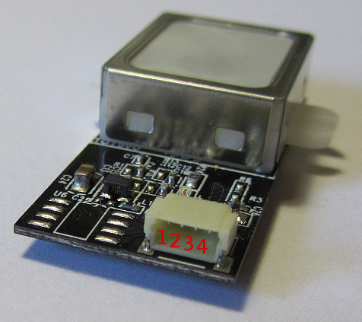

**GT-511C3 Fingerprint Scanner Pin Numbering**

This image shows the pin functions and voltage levels, followed by more details of each pin.

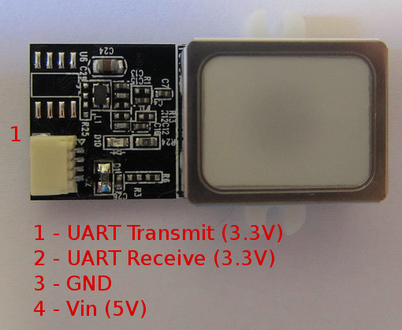

**Pin Functions of the GT-511C3 Fingerprint Scanner**

**Pins 1 and 2** are 3.3V TTL pins used to communicate with the FPS module. The default baud rate is**9600bps** after power on.

**Pin 1** is the transmit pin of the UART on the FPS (UART Tx) and transmits a logic high of up to a maximum of 3.3V.

**Pin 2** is the receive pin of the UART on the FPS (UART Rx) and can receive a logic high level of up to 3.3V. The voltage level sent to this pin from a microcontroller needs to be reduced when working with 5V microcontrollers.

**Pin 3** is the common GND or 0V pin of the FPS module.

**Pin 4** is the 5V input to the FPS module used to power it. This value can be between 4.5V and 6V.

## Connector Specification

The 4 pin connector on the board is a JST-SH series connector with 1mm pin spacing.

A female 4 pin connector is needed to connect four wires to the FPS for interfacing the module to a microcontroller. Ready made cables can be bought, or a cable can be made by buying a crimp housing and pre-crimped wire leads.

The photo below shows pre-crimped wires that are ready to fit into the JST SH 4 way crimp terminal housing.

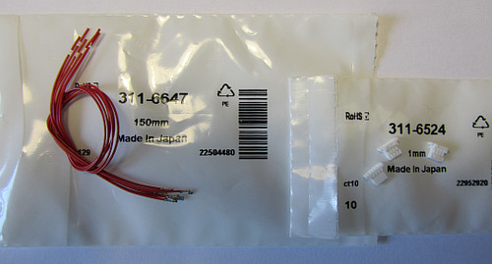

**Pre-crimped Wires (left) and 4 Way JST SH Terminal Housings (right)**

The part numbers for the above parts are:

* **Crimp socket to free end lead, 150mm –** JST part number: SH3-SS5-28150 (RS Components stock number: 311-6647)
* **4 way crimp terminal housing, 1mm pitch –** JST part number: SHR-04V-S-B (RS Components stock number: 311-6524)

The cable is made up by simply inserting four crimped wires into the plastic terminal housing. The image below shows the cable made up and plugged into the FPS module.

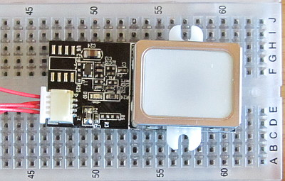

**GT-511C3 Fingerprint Module with Cable Plugged In**

## Interfacing Examples

Two Arduino boards are used to show interfacing with 5V systems (Arduino Uno) and 3.3V systems (Arduino Due).

### Arduino Uno / 5V Microcontroller Interface

When connecting to a microcontroller that uses 5V voltage levels on its pins, a level converter must be used to reduce the 5V output from the microcontroller to the FPS module because the FPS module can only handle 3.3V on its UART pins.

A voltage divider consisting of two resistors can be used as a level converter to reduce the 5V incoming signal to 3.3V. The circuit diagram below shows the fingerprint scanner module connected to an Arduino Uno.

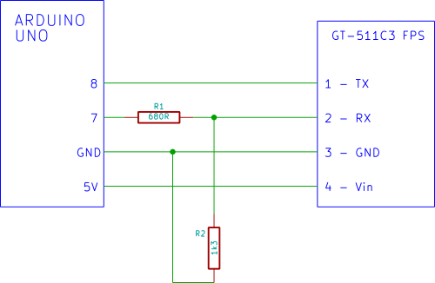

**GT-511C3 Interfaced to an Arduino Uno**

#### Voltage Divider

The circuit below shows the voltage divider from the above circuit diagram. When the Arduino drives its output pin to 5V, the voltage divider reduces this level to 3.3V so that the fingerprint module is not over-driven.

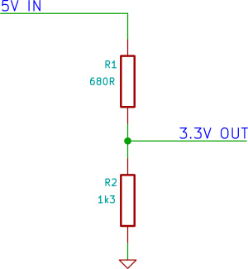

**Voltage Divider / Level Converter Circuit**

The actual calculated voltage output from the above divider circuit is approximately 3.283V.

#### Choosing Voltage Divider Resistors

Other resistor combinations can be used to get a value close to 3.3V output as shown in the table below.

|  |  |  |
| --- | --- | --- |
| **R1** | **R2** | **CALCULATED VOLTAGE** |
| 620Ω | 1k2 | 3.3V |
| 680Ω | 1k3 | 3.28V |
| 560Ω | 1k | 3.21V |
| 1k | 1k8 | 3.21V |

The higher the resistance combination of R1 and R2, the more likely that the communications between the Arduino and SFM will become unreliable due to interference from electrical noise.

The lower the resistance combination of R1 and R2, the more the Arduino pin will be loaded (the lower the resistance, the more current that will be drawn from the pin by the resistors).

### Arduino Due / 3.3V Microcontroller Interface

The Arduino Due does not need any voltage level shifting circuit and can be interfaced directly to the fingerprint module as shown in the circuit diagram below.

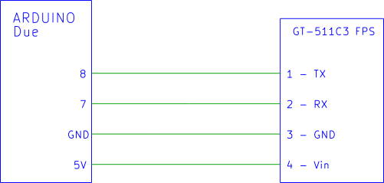

**Interfacing the GT-511C3 to the 3.3V Arduino Due**

The GT-511C3 module must still be powered from 5V which is taken from the Due 5V pin.